2025F Managerial Accounting: Final Project
Forecasting Financial Statements
Company Name: PayPal Holdings Inc.
Student Name: Ritsuko Yoshida

Part I. Company Analysis

1. Business Description
The company PayPal Holdings Inc. is a global financial technology platform that connects consumers with merchants digitally by operating digital payments methods in over 200 countries. Revenue for PayPal comes from the transaction-based use of its platform, which is primarily through merchant fees and additional value-added services including protection against fraud, conversion of currencies for international customers, and credit-type products. PayPal has created a combined ecosystem consisting of its branded checkout services, Peer to Peer (P2P) payment transfers through Venmo, and non-branded processed payments through Braintree. This allows the company to have the ability to create financial connections between all consumers and both small and large enterprise merchants on a larger scale (PayPal Form 10-K, 2024).

In recent quarters, PayPal has continued to adjust its strategic priorities away from transaction volume expansion to improving profitability and cost efficiency. The company has taken significant measures to restructure, including reducing the number of employees and streamlining its operations due to increased competition and a deceleration in consumer spending on e-commerce products worldwide. These initiatives shape the forecasting assumptions used in this analysis, particularly regarding operating cost behavior, liquidity allocation, and capital management (PayPal Form 10-Q, 2025).

2. Industry & Market Analysis
PayPal operates within the global digital payments and financial technology industry, which continues to experience long-term structural growth as a result of consumers moving away from traditional paper money toward cashless options. As digital payments became more common and centralized, competition among technology companies, traditional financial institutions, and fintech startups has intensified, placing increased pressure on pricing and transaction margins. As a result, digital payments industry firms are prioritizing cost efficiency, platform optimization, and disciplined capital management rather than pursuing aggressive, volume-driven growth. Additionally, continuous regulatory requirements and increased investments in cybersecurity further limit profitability across the industry.

PayPal’s ongoing restructuring initiatives, focus on margin stabilization, and disciplined approach to capital management positions the company to align with these evolving industry conditions. These industry dynamics form the basis for the conservative revenue growth assumptions, gradual expense optimization, and prudent balance sheet management reflected in the financial forecasts used in this analysis (Carlsen, 2025; Yahoo Finance, 2025).

Part II. Forecasting Assumptions and Input Explanations

Assumption Table Overview
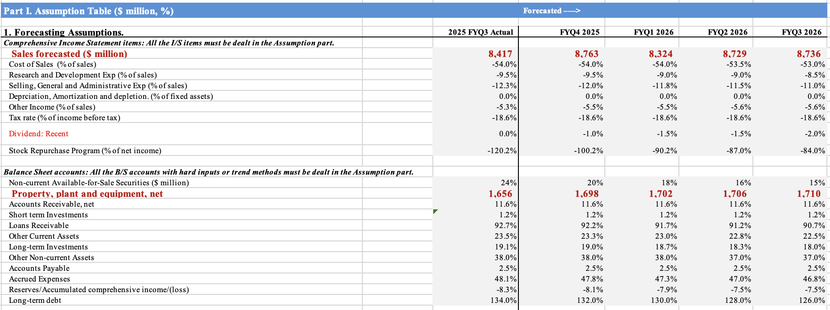

The assumption table above summarizes the key input variables used to develop the forecasted income statement, balance sheet, and cash flow statement. These assumptions are applied consistently across the forecasted periods and serve as the foundation for the financial analyses discussed in the sections that follow.

Revenue Forecasting Context
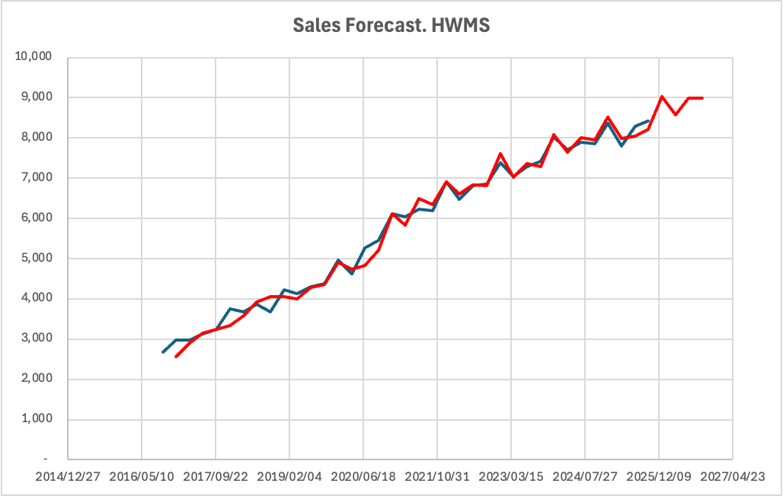

The quarterly sales forecast is based on PayPal's past revenue patterns, along with the unique characteristics of PayPal's transaction activity coming from seasonality. Due to 97% accuracy and high similarity between actual and forecasted data as shown in the graph above, Holt-Winters Multiplicative Seasonal (HWMS) model was chosen to predict both the trend patterns of expected revenues and the consistent seasonal variations in expected revenues that have been observed in PayPal's past revenue numbers. The model also produced a low Mean Absolute Percentage Error (MAPE) of 2.89% when compared against historical revenues, indicating its high predictability.

However, although the HWMS model produces a low MAPE of 2.89%, the forecast is not assumed to be perfectly precise. There is still uncertainty in the forecast due to competitive pricing pressure in the digital payments industry, potential change in consumer transaction behavior, and ongoing operational restructuring at PayPal. As a result, the projections are based on strong historical accuracy but are intentionally kept conservative and not assuming 100% certainty.

- Forecasted 4 Quarters’ Income Statement
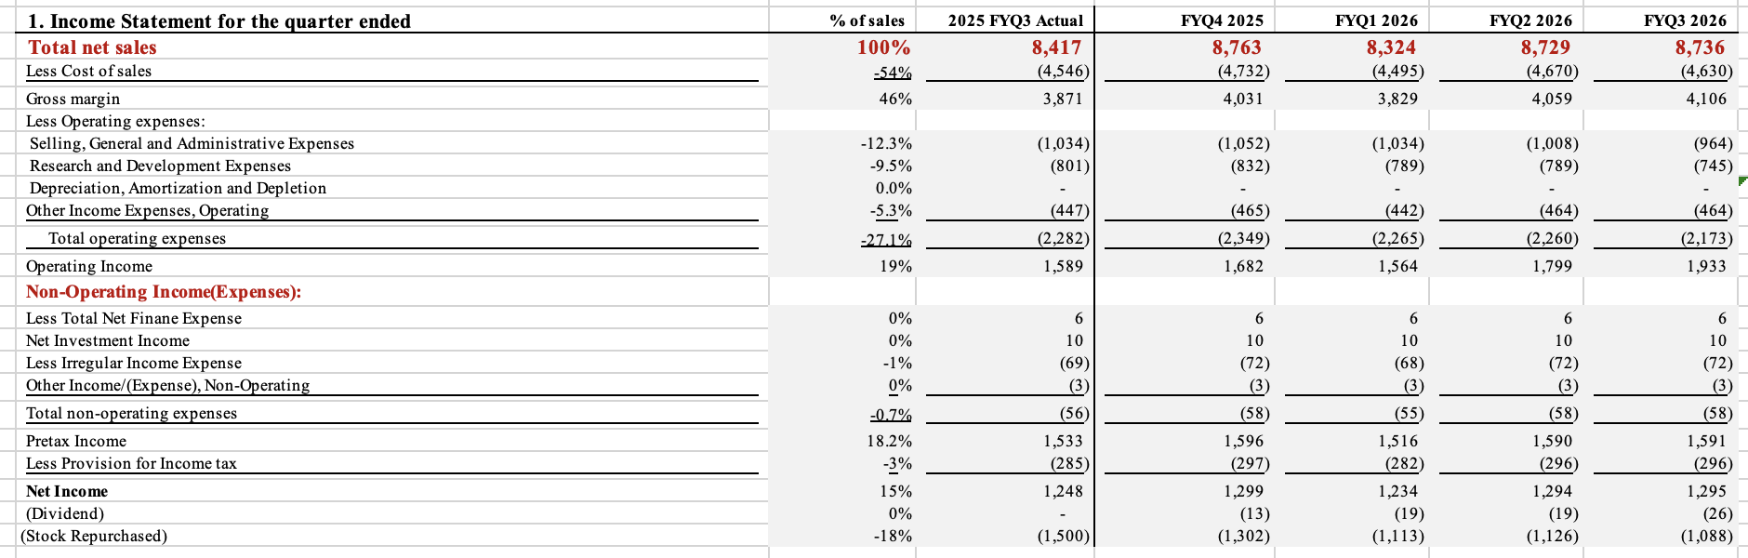

- Sales
Sales are expected to increase slightly across all four quarters during the forecasted period, indicating that PayPal has continued to benefit from the structural growth of digital payments, but also including some impact of competitive pricing pressure and normalization of the e-commerce demand over the short term. The expected sales revenues will not be based on increased volume growth but rather represent stable transaction growth generated from PayPal's primary payment channels such as Venmo and Braintree (Garnett, 2024). This approach aligns with PayPal's focus on improving transaction quality and monetization rather than simply maximizing the number of transactions (PayPal Form 10-Q, 2025; Simply Wall St, 2025).

- Cost of Goods Sold
Cost of goods sold is expected to decrease gradually as a percentage of total sales over the 4 projected quarters, reflecting incremental margin improvement rather than abrupt efficiency gains. COGS is assumed to slightly decrease from approximately 54.0% of sales to around 53.0%, due to cost efficiencies associated with platform consolidation, optimization of PayPal’s payment processing infrastructure, and restructuring-related cost controls. However, because PayPal’s unbranded payment processing services operate at structurally lower margins, overall cost improvements are expected to occur gradually rather than immediately. This assumption results in ideal but also realistic margin expansion consistent with PayPal’s current operational strategy (Carlsen, 2025; Kennedy, 2025).
- Research and Development (R&D) expense
Research and development expenses are forecasted at approximately 8.0% of sales in each of the four projected quarters, reflecting a stable investment profile consistent with PayPal’s recent financial history. This assumption is supported by PayPal’s continued emphasis on AI-driven risk management, fraud prevention, and improved checkout and payments infrastructure, all of which require sustained R&D investment. As a result, R&D spending is expected to remain relatively consistent as PayPal focuses on strengthening platform security and maintaining competitiveness against digital wallet firms such as Apple Pay and Google Pay, rather than making significant cost reductions (Yahoo Finance, 2025; Carlsen, 2025).
- Selling, General, and Administrative (SG&A) expense
Selling, General, and Administrative (SG&A) expenses were projected to decline slightly from 26.5% to 25.5% of sales. This assumption reflects PayPal’s 2025 restructuring initiative, which includes workforce streamlining, reductions in non-essential corporate spending, and simplification of internal operations. These initiatives are expected to create modest cost reductions throughout the forecasted year (Kennedy, 2025).
- Other Operating Income and Expenses
Other operating income and expenses are forecasted as a small and stable percentage of sales based on PayPal’s historical averages. These items are not a primary driver of operating performance and are assumed to remain relatively consistent across the forecasted quarters, reflecting limited volatility in non-core operating activities (PayPal Form 10-Q, 2025).

- Income Taxes, Net Income, and Dividends
Income taxes are estimated using PayPal’s historical effective tax rate applied to forecasted pre-tax income. This rate is assumed to remain stable over the forecast period, as there is no indication of significant changes in tax regulation or geographic revenue mix during this timeframe (PayPal Form 10-Q, 2025). Net income is calculated after subtracting the cost of sales, operating expenses, interest expenses, and income taxes from total revenue. Changes in net income across the forecasted quarters mainly reflect gradual improvements in operating margins driven by cost efficiency initiatives rather than aggressive revenue growth.

Although PayPal did not historically pay dividends, the company initiated its first dividend in October 2025 (Khan, 2025). Including a dividend in the forecast therefore improves realism by aligning the projected financial statements with PayPal’s most recent capital return policy rather than assuming a continuation of past behavior that no longer applies. The assumed payout remains conservative at approximately 1% to 2% of net income, ensuring that the dividend reflects recent practice without significantly affecting liquidity or reinvestment capacity (Carlsen, 2025).

- Forecasted 4 Quarters’ Balance Sheet

Balance sheet accounts are forecasted using a combination of sales-driven relationships, trend-based assumptions, and independent account-specific logic.
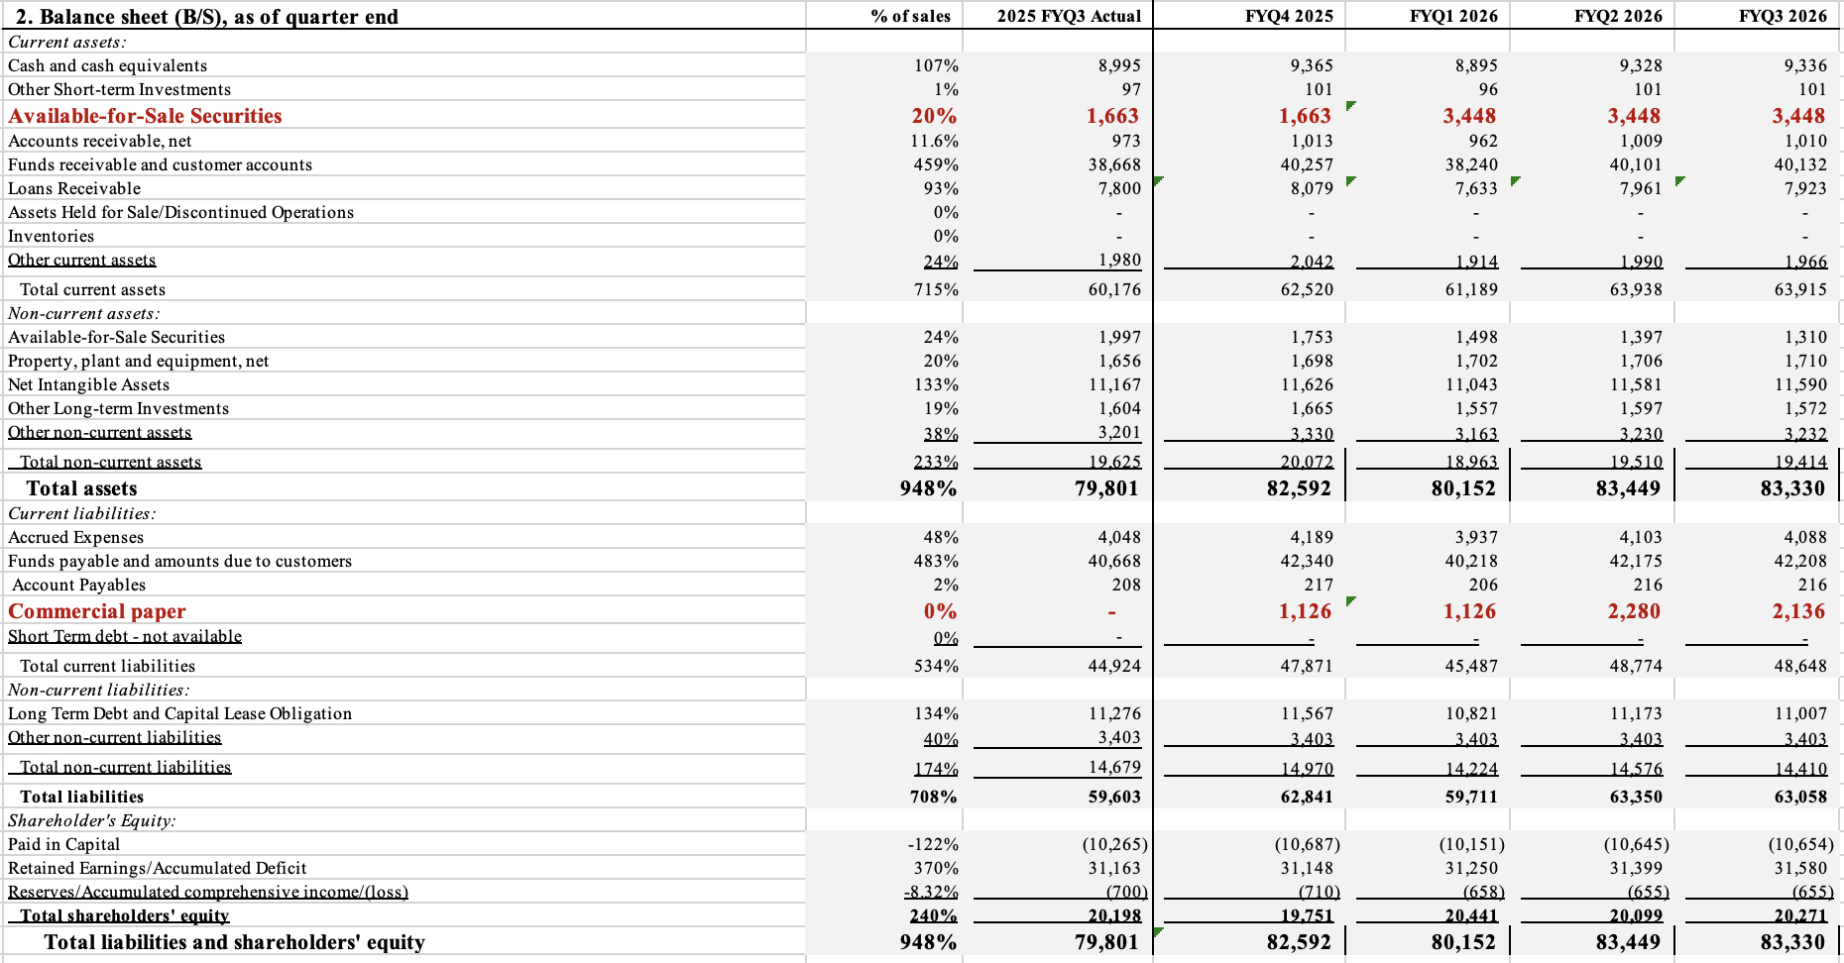

(1) Assets
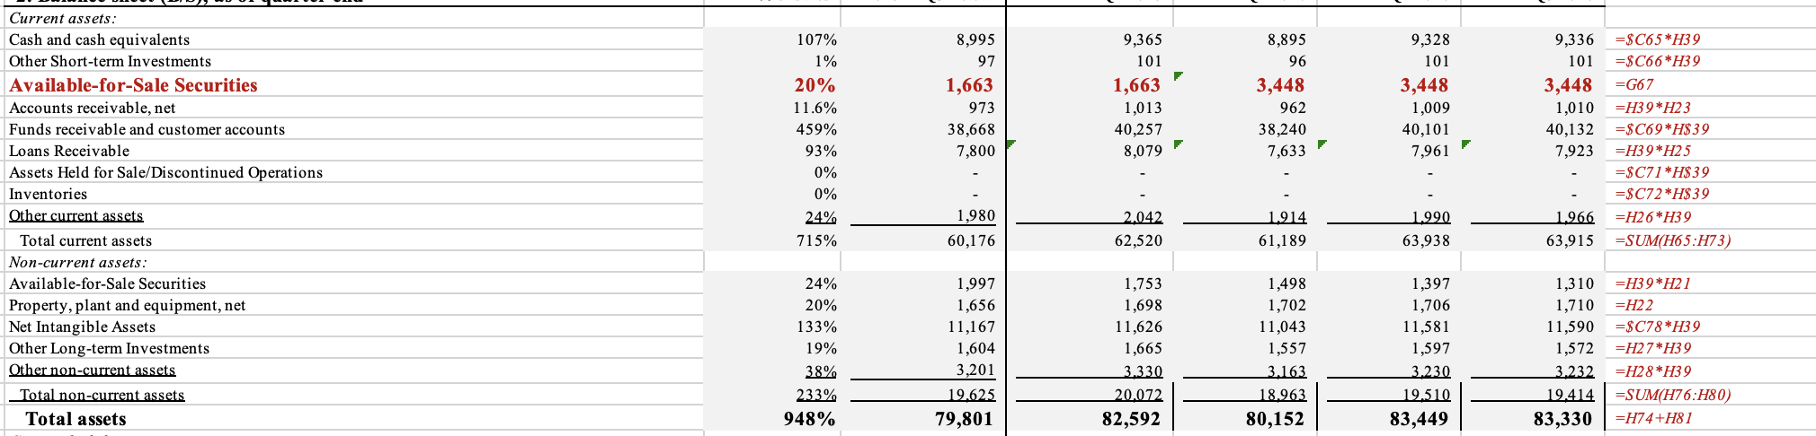

- Cash and Cash Equivalents
Cash balances are assumed to remain relatively stable across the projected timeframe. While PayPal continues to generate positive operating cash flows, excess liquidity is assumed to be partially redeployed toward restructuring costs, infrastructure optimization, and share repurchase activity rather than accumulating the balance sheet. As a result, cash is modeled conservatively without assuming material buildup (PayPal Form 10-Q, 2025).

- Marketable Securities
Marketable securities are expected to decline gradually from around 20% to approximately 15% of total assets over the forecast period, reflecting PayPal’s approach of reallocating excess liquidity toward internal investment needs and shareholder returns rather than maintaining elevated short-term investment balances. The decline is modeled gradually across quarters to remain consistent with PayPal’s historical liquidity management practices and avoid assuming abrupt portfolio reallocation (PayPal Form 10-Q, 2025; Carlsen, 2025).

- Accounts Receivable
Accounts receivable remains relatively stable at approximately 11 to 12% of sales, reflecting consistent merchant settlement timing and no assumed changes in PayPal’s credit policies. Receivables therefore scale proportionally with revenue growth rather than exhibiting independent volatility (Yahoo Finance, 2025).

- Loans Receivable
Loans receivable decline slightly as a percentage of total assets over the forecast period. This reflects PayPal’s continued tightening of underwriting standards and a more cautious approach to credit exposure in response to macroeconomic uncertainty. Growth in credit products is therefore assumed to remain controlled rather than expansionary (Simply Wall St., 2025).

- Property, Plant, and Equipment (Net)
Net property, plant, and equipment are expected to increase slightly over the forecasted quarters. This assumption is based on PayPal’s historical capital expenditure patterns in its recent SEC filings, which show continued but steady investment behavior in technology infrastructure to support platform operations. As a result, capital expenditures are assumed to remain stable and focused on maintaining platform reliability and efficiency (PayPal Form 10-K, 2024; PayPal Form 10-Q, 2025).

- Other Long-Term and Non-Current Assets
Other non-current assets are also assumed to remain relatively stable over the quarters, since there are no major acquisitions or asset reclassifications stated in PayPal’s recent financial report. These balances follow PayPal’s historical trend and are therefore not modeled as a primary driver of balance sheet growth in the forecast (PayPal Form 10-K, 2024).

(2) Liabilities
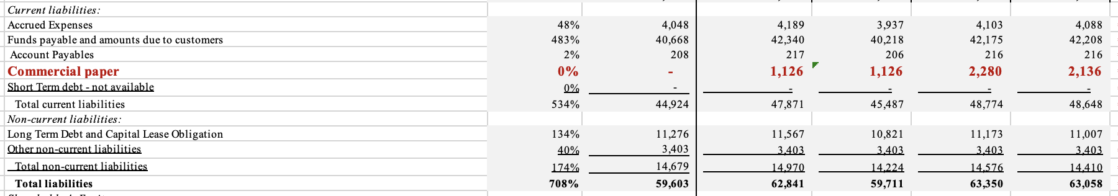
- Accounts Payable and Accrued Expenses
Accounts payable and accrued expenses are expected to remain constant with the operating activity. Accrued expenses decrease slightly as restructuring initiatives could potentially reduce compensation-related liabilities over time, while payables could continue to scale with operating volume without material changes in payment terms (Kennedy, 2025).

- Funds Payable and Amounts Due to Customers
Funds payable and amounts due to customers are assumed to move closely with transaction volume, since PayPal primarily acts as an intermediary that temporarily holds customer funds during the settlement process. Since there seems to be no major changes in settlement timing or customer behavior during the forecast period, these balances are expected to grow steadily with revenue (PayPal Form 10-Q, 2025).

- Commercial Paper and Short-Term Borrowing
Short-term borrowing is included only to manage temporary cash timing differences and is not intended to change PayPal’s overall financing strategy. While PayPal did not rely on commercial paper in the past financial records, it has been added in the forecast period to showcase minimal potential use given the company’s strong credit profile and continued access to short-term funding markets. Thus, any commercial paper assumed in the forecast is treated as temporary and used only to manage short-term liquidity timing, rather than representing a structural increase in purchases (PayPal Form 10-Q, 2025; Yahoo Finance, 2025).

- Long-Term Debt
Long-term debt is projected to decline gradually as existing obligations mature, falling from approximately 130% toward the mid-120% range relative to equity over the forecast horizon. No major new debt issuance is assumed, consistent with PayPal’s conservative leverage strategy (Simply Wall St., 2025).

(3) Equity
- Retained Earnings
Retained earnings are expected to increase steadily over the forecast period, driven primarily by positive net income generation. This growth is partially offset by continued share of repurchase activity, consistent with PayPal’s capital return strategy.

- Share Repurchases and Equity Adjustments
Shareholders’ equity reflects ongoing share repurchases, which reduce total equity despite positive earnings. This assumption aligns with management’s stated intention to return capital to shareholders while maintaining sufficient liquidity for operational needs (Carlsen, 2025).

- Forecasted Statement of Cash Flows

The forecasted statement of cash flow below highlights PayPal’s ability to generate consistent operating cash flows while taking a consistent approach to capital allocation among ongoing restructuring and competition.
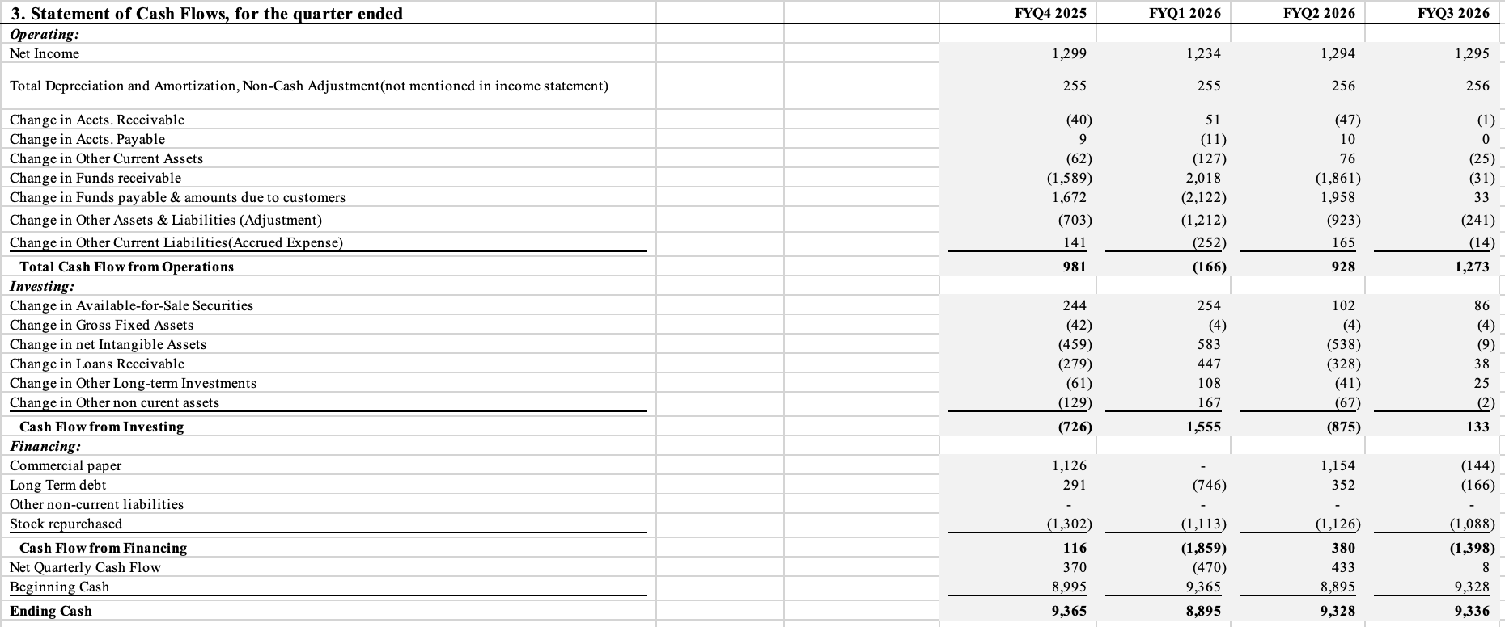
- Cash Flows in Operating
Cash flows value in operating activities was mostly positive throughout the forecasted quarters and move relatively with net income. Operating cash flow is expected to be around $980 million to $1.27 billion per quarter, and in most periods, the values were same or above net income since non-cash expenses such as depreciation and amortization were included within the calculation.

The quarterly fluctuations in operating cash flow are mainly driven by changes in working capital accounts, such as accounts receivable, accounts payable, and funds payable to customers. The forecast also incorporates an aggregated adjustment for changes in other operating assets and liabilities. This adjustment captures cash movements related to settlement timing, merchant reserves, foreign exchange effects, and similar operational items that are reported in aggregate in PayPal’s financial statements but are not modeled separately in this forecast. Including this adjustment helps maintain consistency between the forecasted balance sheet and cash flow statement, without suggesting changes in PayPal’s underlying operating performance.

- Cash Flows in Investing
Cash flows from investing activities are expected to be negative in most quarters over the forecast period. Net investing cash flow fluctuates between approximately –$875 million and $1.56 billion, driven mainly by capital expenditures and changes in marketable securities. Capital expenditures are assumed to remain fairly consistent and focused on maintaining and improving PayPal’s platform and infrastructure, rather than supporting expansion-related projects.

In some of the forecasted quarters, investing cash flow turns positive because partial short-term investments are converted into cash in the forecast, which helps offset capital expenditures. Overall, investing activity is expected to be less compared to operating cash inflows, aligned with a cautious reinvestment assumption of PayPal.

- Cash Flows in Financing
Cash flows from financing activities are mainly driven by share repurchases, which result in net cash outflows in most forecasted quarters. Share repurchases are expected to be approximately $1.1 billion to $1.3 billion per quarter, making them the primary use of financing cash flows in the forecast. Limited short-term borrowing, such as commercial paper, is assumed in certain quarters to help manage short-term liquidity timing, rather than to support long-term financing needs. Additionally, there are no assumptions on new long-term debt issuance, which is consistent with PayPal’s conservative leverage profile and focus on maintaining balance sheet flexibility.

Part III. Comparative Analysis with Financial Ratios

The below analysis indicates PayPal’s forecasted financial performance using key financial ratios calculated from the projected income statement, balance sheet, and cash flow statement.
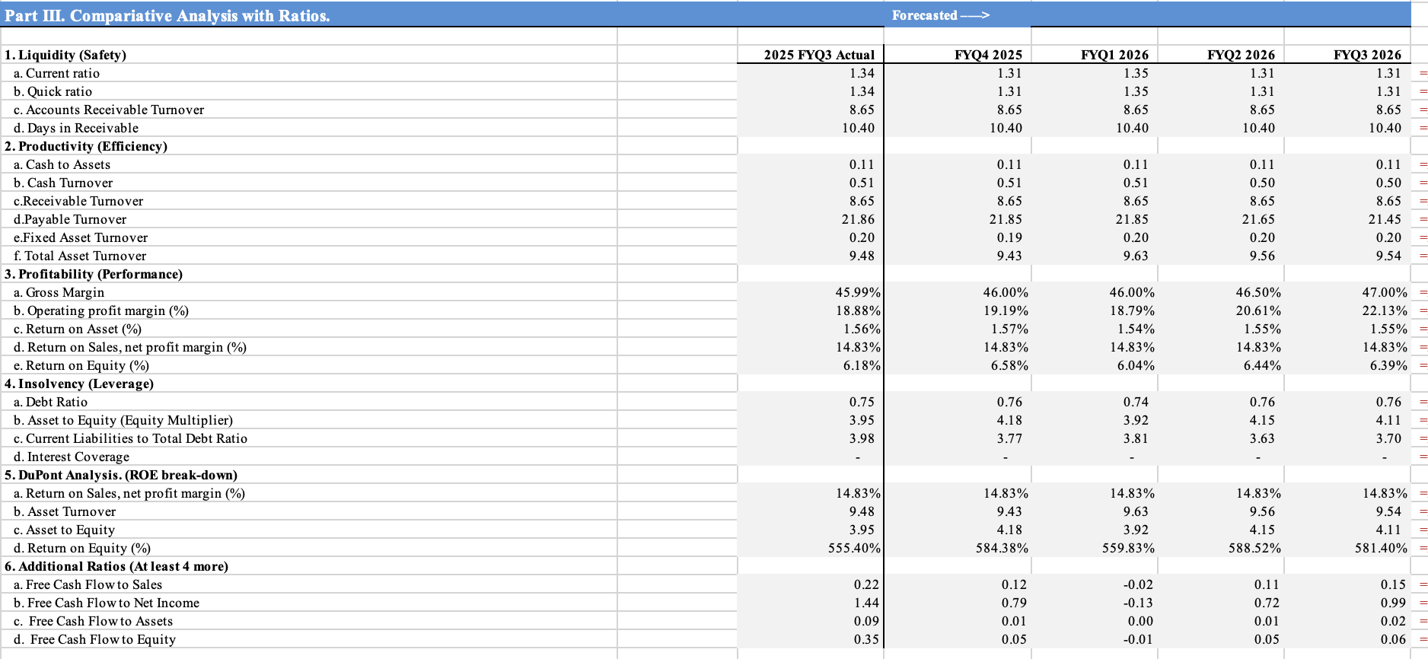

1) Liquidity (Safety)
- Current Ratio
PayPal’s current ratio stays consistent across the forecasted quarters, ranging between 1.31 and 1.35. This range is consistent with PayPal’s recent actual quarter and shows management’s emphasis on maintaining sufficient short-term liquidity while avoiding excess assets. Based on historical balance sheet patterns in PayPal’s Form 10-Q, current assets and current liabilities are assumed to scale proportionally with revenue, resulting in a stable ratio throughout the forecast period (PayPal Form 10-Q, 2025).

- Quick Ratio
The quick ratio also has a similar pattern with the current ratio, remaining stable across the forecasted period. This assumption is based on PayPal’s balance sheet structure, where the majority of current assets have cash, marketable securities, and receivables rather than inventory. As a result, excluding less liquid current assets does not significantly change PayPal’s liquidity position.

- Accounts Receivable Turnover
Accounts' receivable turnover value remains constant at 8.65 over the forecasted quarters. This assumption is based on PayPal’s transaction-based revenue model, where receivables are collected over short and fairly stable time periods. This stability in growth is further supported with historical data from PayPal’s Form 10-Q (PayPal Form 10-Q, 2025).

- Days in Receivable
Days in receivable have no changes with 10.40 days across the forecasted timeline, and this aligns with PayPal’s transaction-based business model, where transaction settlement timing is largely automated and not expected to deteriorate with revenue growth. Past financial data also has no significant fluctuations in days outstanding, supporting the assumption of stable working capital efficiency throughout the forecast period (PayPal Form 10-Q, 2025).

2) Productivity (Efficiency)
- Cash to Assets
The cash-to-assets ratio is forecasted to remain near 0.11 across the projected quarters. This assumption is based on PayPal’s historical balance sheet trends, where cash levels have generally moved in proportion to total assets rather than increasing aggressively on their own (Yahoo Finance, 2025).

- Cash Turnover
Cash turnover decreased slightly from 0.51 to 0.50, which potentially indicates a slight slowdown in how quickly cash moves through the business. The value is consistent during the forecast period, since PayPal is assumed to be holding more cash while managing restructuring efforts and competitive pricing pressure. The change is also minor and does not signify any meaningful decline in operating efficiency.

- Receivable Turnover
Accounts' receivable turnover remains stable throughout the forecast period. This aligns with PayPal’s short settlement cycles and transaction-driven revenue structure. Past financial statements indicate minimal fluctuation in receivable turnover, suggesting that collection efficiency should remain consistent even as transaction volume increases (Yahoo Finance, 2025).

- Payable Turnover
Payable turnover has forecasted to decline slightly from 21.86 to 21.45, reflecting modest extensions in payment timing. This assumption is consistent with normal working capital management and PayPal’s ability to use its scale to manage payment obligations efficiently. The change follows historical patterns and does not suggest increased financial risk or strain on supplier relationships (PayPal Form 10-Q, 2025).

- Fixed Asset Turnover
Fixed asset turnover remains stable across the forecasted quarters, which is consistent with current PayPal’s operating systems. Because the business relies primarily on digital platforms rather than physical infrastructure, no major increases in fixed assets are assumed in the forecast. As a result, fixed asset efficiency is expected to remain the same with historical performance rather than change materially (PayPal Form 10-K, 2024).

- Total Asset Turnover
Total asset turnover projection fluctuates slightly between 9.43 and 9.63, indicating that PayPal’s ability to generate revenue from its asset base is consistent throughout. This assumption is supported through Morningstar’s analysis of PayPal, which highlights the company’s ability to scale revenue without requiring significant growth in total assets. As no major acquisitions or asset-intensive investments are assumed during the forecasted quarters though past data, overall asset utilization is expected to be stable (Horn, 2025).

3) Profitability (Performance)
- Gross Margin
Gross margin is expected to increase from 46.0% to 47.0% over the projected periods. This assumption is based on a slight decrease in cost of sales as a percentage of revenue, reflecting improved efficiency from platform consolidation and restructuring efforts. However, because a significant portion of PayPal’s revenue comes from unbranded payment processing services such as Braintree, which have lower margins, the forecast does not assume a significant change in gross margin. Instead, margins were made to improve slowly and remain within a realistic range based on recent performance (PayPal Form 10-Q, 2025; Kennedy, 2025).

- Operating Profit Margin
Operating profit margin is forecasted to increase from 18.9% to 22.1% over the quarters. This improvement is mainly driven by SG&A expenses declining as a percentage of sales following workforce reductions and operational streamlining identified in external analysis (Kennedy, 2025). R&D spending is assumed to stay relatively stable, so the improvement in margins comes from managing costs more efficiently rather than cutting back on long-term investments. Overall, the increase reflects gradual improvements in efficiency rather than short-term or one-time cost savings.

- Return on Assets (ROA)
Return on assets remains close to 1.55% throughout the forecast period. While operating profitability improves, total assets are also assumed to grow as revenue and transaction volume increase. This means that higher earnings are largely absorbed by balance sheet growth rather than translating into a higher ROA. This outcome is consistent with PayPal’s business structure, where growth in payment activity requires holding higher balances in cash, receivables, and customer-related funds, resulting in gradual rather than sharp changes in asset returns (Simply Wall St., 2025).

- Net Profit Margin (Return on Sales)
Net profit margin remains at approximately 14.8% across the forecasted quarters. This reflects the assumption that gains in operating efficiency are largely balanced by stable tax rates and non-operating expenses. Because no significant changes in tax policy, geographic revenue mix, or financing structure are assumed during the forecast period, net profitability is expected to remain relatively consistent even as operating margins improve. Overall, the stability in net margin supports the conservative nature of the forecast rather than indicating a lack of operational improvement (PayPal Form 10-Q, 2025).

- Return on Equity (ROE)
Return on equity increases slightly but remains somewhat volatile, ranging between 6.0% and 6.6% over the timeframe. This movement is driven primarily by changes in net income rather than shifts in leverage. Because the forecast assumes no material increase in debt and continued share repurchases that reduce equity, ROE responds more to earnings' fluctuations than capital structure changes. This aligns with PayPal’s stated emphasis on shareholder returns through buybacks rather than leverage expansion (Yahoo Finance, 2025).

4) Insolvency (Leverage)
- Debt Ratio
The debt ratio stays within a narrow range of 0.75 to 0.76 over the forecast period. This reflects the assumption that PayPal does not increase its use of debt but relies mainly on internally generated cash to fund operations. Thus, holding the ratio steady aligns with the broader assumption that PayPal focuses on maintaining balance sheet flexibility while managing restructuring efforts, rather than taking on additional leverage to drive growth (PayPal Form 10-Q, 2025).

- Asset to Equity (Equity Multiplier)
The equity multiplier fluctuates between 3.9 and 4.2, reflecting a largely unchanged capital structure. Minor variation is driven by changes in equity from retained earnings and share of repurchase activity rather than increases in total debt. This supports the assumption that leverage remains controlled and that changes in shareholder returns are driven by operating performance rather than financial engineering (Yahoo Finance, 2025).

- Current Liabilities to Total Debt Ratio
The ratio of current liabilities to total debt declines slightly over the forecast period. This mainly reflects small changes in working capital and the mix of liabilities rather than any change in PayPal’s financing approach. Since no meaningful increase in short-term borrowing is assumed, the decline is driven by timing differences rather than higher leverage (PayPal Form 10-Q, 2025).

- Interest Coverage
Interest coverage is not a binding constraint in the forecast, as operating income remains well above interest expense across all projected quarters. This outcome reflects PayPal’s limited reliance on interest-bearing debt and supports the assumption that financing risk remains low throughout the forecast horizon. As a result, interest coverage does not materially influence PayPal’s operational or capital allocation decisions in the forecasted period (Simply Wall St., 2025).

5) DuPont ratio analysis
The DuPont analysis indicates that changes in PayPal’s return on equity over the forecast period are mostly driven by improvements in operating margins. Net profit margin stays fairly stable across the forecasted quarters, which suggests that the increase in equity returns comes from cost management and restructuring efforts rather than faster revenue growth. This is consistent with PayPal’s recent focus on improving profitability while operating in a competitive digital payments market, as discussed in its recent quarterly filings (PayPal Form 10-Q, 2025).

Asset turnover shows only minor variation throughout the forecast period, consistent with the assumption that PayPal’s total assets grow in line with transaction volume and revenue. As payment activity increases, higher balances in cash, receivables, and customer-related funds are required to support operations, which limits significant changes in asset efficiency. This supports the expectation that improvements in equity returns are not driven by changes in asset usage (Simply Wall St., 2025).

The equity multiplier remains broadly stable over the forecast horizon, reflecting the assumption that PayPal does not meaningfully increase its use of debt financing. Instead, the forecast assumes continued reliance on internally generated cash flows and share repurchases, rather than leverage, to manage capital structure. As a result, the DuPont framework confirms that forecasted changes in return on equity are primarily the result of internal efficiency improvements and margin stabilization, rather than increased leverage or balance sheet expansion (PayPal Form 10-Q, 2025).

6) Additional ratio analysis
- Free Cash Flow to Sales
Free cash flow to sales declines from 0.22 in the actual quarter to 0.12 in FYQ4 2025, turns slightly negative at –0.02 in FYQ1 2026, and then recovers to 0.15 by FYQ3 2026. Compared to PayPal’s recent historical performance, this short-term decline reflects the timing of restructuring-related cash outflows, capital expenditures, and working capital changes included in the forecasted cash flow statement rather than a slowdown in revenue generation.

Because free cash flow is calculated as operating cash flow - capital expenditures, it is more sensitive to near-term cash timing than sales. Historical cash flow disclosures show similar quarter-to-quarter variability during periods of restructuring and investment, supporting the assumption that this fluctuation is temporary rather than structural (PayPal Form 10-Q, 2025).

- Free Cash Flow to Net Income
The free cash flow to net income ratio declines from 1.44 in the actual quarter to 0.79, turns negative at –0.13 in FYQ1 2026, and then improves to 0.99 by FYQ3 2026. This divergence from historical levels occurs because net income smooths expenses over time, while free cash flow reflects the actual timing of cash payments related to restructuring costs and working capital adjustments.

PayPal’s historical statements show that free cash flow can temporarily diverge from net income during periods of operational transition, supporting the forecast assumption that the early decline reflects timing effects rather than weakened earnings quality (PayPal Form 10-Q, 2025).

- Free Cash Flow to Assets
Free cash flow to assets declined from 0.09 in the actual quarter to near zero in FYQ1 2026, before recovering to 0.02 by FYQ3 2026. This ratio is directly calculated using forecasted free cash flow divided by total assets, both of which are derived from the projected financial statements.

The short-term decline reflects the assumption that total assets continue to grow modestly with transaction volume and platform investment, while free cash flow is temporarily pressured by restructuring-related outflows. As these pressures ease, the ratio improves, consistent with PayPal’s historical ability to generate cash without materially reducing its asset base (Simply Wall St., 2025).

- Free Cash Flow to Equity
Free cash flow to equity declines from 0.35 in the actual quarter to 0.05, turns slightly negative at –0.01 in FYQ1 2026, and then recovers to 0.06 by FYQ3 2026. This movement reflects the combined impact of operating cash flow timing, capital expenditures, and continued share repurchases modeled in the forecast.

Historically, PayPal’s shareholder returns have been funded primarily through operating cash flows rather than increased leverage. The recovery in free cash flow to equity later in the forecast supports the assumption that shareholder distributions remain sustainable without relying on additional long-term debt (PayPal Form 10-Q, 2025).

References
Carlsen, C. (2025). Is It Time to Buy PayPal Stock in 2025? Nasdaq.com. /it-time-buy-paypal-stock-2025https://www.nasdaq.com/articles/it-time-buy-paypal-stock-2025
Garnett, A. G. (2024, March 30). Britannica Money. Www.britannica.com. https://www.britannica.com/money/PayPalhttps://www.britannica.com/money/PayPal
Horn, B. (2025, October 3). PayPal Remains a Somewhat Unique Player Within the Payments Space. Morningstar, Inc. https://www.morningstar.com/company-reports/1344603--somewhat--within-?listing=0P00016CGN-somewhat-unique-player-within-the-payments-space?listing=0P00016CGN
Kennedy, R. (2025, August 1). Inside PayPal’s restructuring plans. Payment Expert. https://paymentexpert.com/2025/08/01/inside-paypals-//
Khan, F. H. (2025, October 30). PayPal Is Paying Its First-Ever Dividend. Should You Snap Up PYPL Stock Now? Yahoo Finance. https://finance.yahoo.com/news/paypal-paying-first-ever-dividend-233002875.html
PayPal. (2024). PayPal Holdings, Inc. - Home. Pypl.com. /https://investor.pypl.com/
PayPal. (2025). Send Money, Pay Online or Set Up a Merchant Account - PayPal. Www.paypal.com. https://www.paypal.com
PayPal Holdings, Inc. (2025). UNITED STATES SECURITIES AND EXCHANGE COMMISSION FORM 10-Q. /31b61ad8-8833-46f4-871d-1d4a0b78f743.pdfhttps://d18rn0p25nwr6d.cloudfront.net/CIK-0001633917/31b61ad8-8833-46f4-871d-1d4a0b78f743.pdf
PitchBook. (2025). PayPal Holdings (NAS: PYPL). Pitchbook.com. /financials/KEY_METRICShttps://my.pitchbook.com/profile/10727-11/company/financials/KEY_METRICS
Simply Wall St. (2025, December 6). What Analysts Think Is Changing the Story for PayPal and Its Future Edge Over Competitors. Yahoo Finance. https://finance.yahoo.com/news/analysts-think-changing-story-paypal-070630035.html
Yahoo Finance. (2025). PayPal Holdings, Inc. (PYPL) Stock Price, News, Quote & History - Yahoo Finance. Finance.yahoo.com. https://finance.yahoo.com/quote/PYPL/ https://finance.yahoo.com/quote/PYPL/

